|  |  |  |  |  |
| --- | --- | --- | --- | --- |
| Fecha | Versión | Incidencias | Entrega | Comentario |
| 24/11/2022 | Inicial | 8 |  | No se ha podido probar la funcionalidad al no mostrarse los registros en la tabla. |
| 02/12/2022 |  | 5 |  |  |
| 13/12/2022 | v.2 | 2 | 13/12/2022 13:04 | No se habilita el botón de Descartar. Error al no incluir el comentario en la entrega. |

**PANTALLA EJECUTAR**

1. Tenemos dos scripts para ejecutar sin histórico. Seleccionamos solo el primero y lo ejecutamos sin error. Si seleccionamos el script no se está habilitando el botón de Descartar y no se puede probar dicha funcionalidad. En el documento se indica lo siguiente:

*Si hay scripts de histórico ejecutados correctamente (aunque solo sea uno), el botón de* ***Descartar*** *estará siempre deshabilitado.*

*En caso contrario:*

* *Si se selecciona un script con estado* ***Ejecutado*** *en la tabla de vigente, se habilitará el botón* ***Descartar****. En caso contrario, el botón permanecerá deshabilitado.*
* *Si se pulsa el botón* ***Descartar****, se mostrará la pantalla (modal) Descartar Script (ver punto Pantalla Descartar Script).*

1. Volvemos a procesar un script que genera dos ficheros. Ejecutamos el primero sin errores. Actualiza sus datos en el listado. Ejecutamos el segundo sin errores y nos redirige a la pantalla de resumen. Pulsamos entregar y se produce un error:

12:22:16.701 [AWT-EventQueue-0] INFO c.m.u.l.PantallaResumenProcesadoActionListener - Zip file name: \\Nes011901-007\modelodatos\TEMPORAL_PUESTOS_VIRTUALES\MARIPAM\MDSQL_JAVA\pruebas\MDSQL_IGR\20221124_12_18_MDSQL_IGR_DD_SDFFFFF.zip

12:22:16.785 [AWT-EventQueue-0] INFO c.m.u.l.PantallaResumenProcesadoActionListener - Ruta entregados: C:\MDSQL_JAVA\scripts\creacionTablasSMD_LD\Entregable

12:22:16.790 [AWT-EventQueue-0] ERROR c.m.u.l.PantallaResumenProcesadoActionListener - \\Nes011901-007\modelodatos\TEMPORAL_PUESTOS_VIRTUALES\MARIPAM\MDSQL_JAVA\pruebas\MDSQL_IGR\20221124_12_18_MDSQL_IGR_DD_SDFFFFF.zip -> C:\MDSQL_JAVA\scripts\creacionTablasSMD_LD\Entregable\20221124_12_18_MDSQL_IGR_DD_SDFFFFF.zip

12:22:16.790 [AWT-EventQueue-0] ERROR c.m.u.l.PantallaResumenProcesadoActionListener - C:\MDSQL_JAVA\scripts\creacionTablasSMD_LD\20221124_12_18_MDSQL_IGR_DD_SDFFFFF.sql -> C:\MDSQL_JAVA\scripts\creacionTablasSMD_LD\Entregable\20221124_12_18_MDSQL_IGR_DD_SDFFFFF.sql

12:22:16.791 [AWT-EventQueue-0] ERROR c.m.u.l.PantallaResumenProcesadoActionListener - C:\MDSQL_JAVA\scripts\creacionTablasSMD_LD\20221124_12_18_MDSQL_IGR_DC_SDFFFFF.pdc -> C:\MDSQL_JAVA\scripts\creacionTablasSMD_LD\Entregable\20221124_12_18_MDSQL_IGR_DC_SDFFFFF.pdc

12:22:16.792 [AWT-EventQueue-0] INFO c.m.b.service.impl.ServiceSupport - {call SM2_K_LD_MDSQL_MARIPAM.P_ENTREGAR_PETICION(?,?,?,?,?,?)}

12:22:16.794 [AWT-EventQueue-0] INFO c.m.b.service.impl.ServiceSupport - Parßmetros de entrada:

394

MARIPAM

NULL

Exception in thread "AWT-EventQueue-0" java.security.PrivilegedActionException: java.security.PrivilegedActionException: com.mdval.exceptions.ServiceException

at java.security.AccessController.doPrivileged(Native Method)

at java.security.ProtectionDomain$JavaSecurityAccessImpl.doIntersectionPrivilege(Unknown Source)

at java.awt.EventQueue.dispatchEvent(Unknown Source)

at java.awt.EventDispatchThread.pumpOneEventForFilters(Unknown Source)

at java.awt.EventDispatchThread.pumpEventsForFilter(Unknown Source)

at java.awt.EventDispatchThread.pumpEventsForFilter(Unknown Source)

at java.awt.WaitDispatchSupport$2.run(Unknown Source)

at java.awt.WaitDispatchSupport$4.run(Unknown Source)

at java.awt.WaitDispatchSupport$4.run(Unknown Source)

at java.security.AccessController.doPrivileged(Native Method)

at java.awt.WaitDispatchSupport.enter(Unknown Source)

at java.awt.Dialog.show(Unknown Source)

at java.awt.Component.show(Unknown Source)

at java.awt.Component.setVisible(Unknown Source)

at java.awt.Window.setVisible(Unknown Source)

at java.awt.Dialog.setVisible(Unknown Source)

at com.mdval.ui.utils.UIHelper.show(UIHelper.java:63)

at com.mdsql.ui.listener.FramePrincipalActionListener.evtEjecutar(FramePrincipalActionListener.java:379)

at com.mdsql.ui.listener.FramePrincipalActionListener.actionPerformed(FramePrincipalActionListener.java:96)

at javax.swing.AbstractButton.fireActionPerformed(Unknown Source)

at javax.swing.AbstractButton$Handler.actionPerformed(Unknown Source)

at javax.swing.DefaultButtonModel.fireActionPerformed(Unknown Source)

at javax.swing.DefaultButtonModel.setPressed(Unknown Source)

at javax.swing.plaf.basic.BasicButtonListener.mouseReleased(Unknown Source)

at java.awt.AWTEventMulticaster.mouseReleased(Unknown Source)

at java.awt.Component.processMouseEvent(Unknown Source)

at javax.swing.JComponent.processMouseEvent(Unknown Source)

at java.awt.Component.processEvent(Unknown Source)

at java.awt.Container.processEvent(Unknown Source)

at java.awt.Component.dispatchEventImpl(Unknown Source)

at java.awt.Container.dispatchEventImpl(Unknown Source)

at java.awt.Component.dispatchEvent(Unknown Source)

at java.awt.LightweightDispatcher.retargetMouseEvent(Unknown Source)

at java.awt.LightweightDispatcher.processMouseEvent(Unknown Source)

at java.awt.LightweightDispatcher.dispatchEvent(Unknown Source)

at java.awt.Container.dispatchEventImpl(Unknown Source)

at java.awt.Window.dispatchEventImpl(Unknown Source)

at java.awt.Component.dispatchEvent(Unknown Source)

at java.awt.EventQueue.dispatchEventImpl(Unknown Source)

at java.awt.EventQueue.access$500(Unknown Source)

at java.awt.EventQueue$3.run(Unknown Source)

at java.awt.EventQueue$3.run(Unknown Source)

at java.security.AccessController.doPrivileged(Native Method)

at java.security.ProtectionDomain$JavaSecurityAccessImpl.doIntersectionPrivilege(Unknown Source)

at java.security.ProtectionDomain$JavaSecurityAccessImpl.doIntersectionPrivilege(Unknown Source)

at java.awt.EventQueue$4.run(Unknown Source)

at java.awt.EventQueue$4.run(Unknown Source)

at java.security.AccessController.doPrivileged(Native Method)

at java.security.ProtectionDomain$JavaSecurityAccessImpl.doIntersectionPrivilege(Unknown Source)

at java.awt.EventQueue.dispatchEvent(Unknown Source)

at java.awt.EventDispatchThread.pumpOneEventForFilters(Unknown Source)

at java.awt.EventDispatchThread.pumpEventsForFilter(Unknown Source)

at java.awt.EventDispatchThread.pumpEventsForHierarchy(Unknown Source)

at java.awt.EventDispatchThread.pumpEvents(Unknown Source)

at java.awt.EventDispatchThread.pumpEvents(Unknown Source)

at java.awt.EventDispatchThread.run(Unknown Source)

Caused by: java.security.PrivilegedActionException: com.mdval.exceptions.ServiceException

at java.security.AccessController.doPrivileged(Native Method)

at java.security.ProtectionDomain$JavaSecurityAccessImpl.doIntersectionPrivilege(Unknown Source)

at java.security.ProtectionDomain$JavaSecurityAccessImpl.doIntersectionPrivilege(Unknown Source)

at java.awt.EventQueue$4.run(Unknown Source)

at java.awt.EventQueue$4.run(Unknown Source)

... 56 more

Caused by: com.mdval.exceptions.ServiceException

at com.mdsql.bussiness.service.impl.ServiceSupport.buildException(ServiceSupport.java:64)

at com.mdsql.bussiness.service.impl.ServiceSupport.buildException(ServiceSupport.java:46)

at com.mdsql.bussiness.service.impl.EntregaServiceImpl.entregarPeticion(EntregaServiceImpl.java:112)

at com.mdsql.ui.listener.PantallaResumenProcesadoActionListener.evtEntregar(PantallaResumenProcesadoActionListener.java:103)

at com.mdsql.ui.listener.PantallaResumenProcesadoActionListener.actionPerformed(PantallaResumenProcesadoActionListener.java:65)

at javax.swing.AbstractButton.fireActionPerformed(Unknown Source)

at javax.swing.AbstractButton$Handler.actionPerformed(Unknown Source)

at javax.swing.DefaultButtonModel.fireActionPerformed(Unknown Source)

at javax.swing.DefaultButtonModel.setPressed(Unknown Source)

at javax.swing.plaf.basic.BasicButtonListener.mouseReleased(Unknown Source)

at java.awt.Component.processMouseEvent(Unknown Source)

at javax.swing.JComponent.processMouseEvent(Unknown Source)

at java.awt.Component.processEvent(Unknown Source)

at java.awt.Container.processEvent(Unknown Source)

at java.awt.Component.dispatchEventImpl(Unknown Source)

at java.awt.Container.dispatchEventImpl(Unknown Source)

at java.awt.Component.dispatchEvent(Unknown Source)

at java.awt.LightweightDispatcher.retargetMouseEvent(Unknown Source)

at java.awt.LightweightDispatcher.processMouseEvent(Unknown Source)

at java.awt.LightweightDispatcher.dispatchEvent(Unknown Source)

at java.awt.Container.dispatchEventImpl(Unknown Source)

at java.awt.Window.dispatchEventImpl(Unknown Source)

at java.awt.Component.dispatchEvent(Unknown Source)

at java.awt.EventQueue.dispatchEventImpl(Unknown Source)

at java.awt.EventQueue.access$500(Unknown Source)

at java.awt.EventQueue$3.run(Unknown Source)

at java.awt.EventQueue$3.run(Unknown Source)

... 61 more

El fichero ZIP lo ha creado en la ruta que indica el log:

\\Nes011901-007\modelodatos\TEMPORAL_PUESTOS_VIRTUALES\MARIPAM\MDSQL_JAVA\pruebas\MDSQL_IGR\20221124_12_18_MDSQL_IGR_DD_SDFFFFF.zip

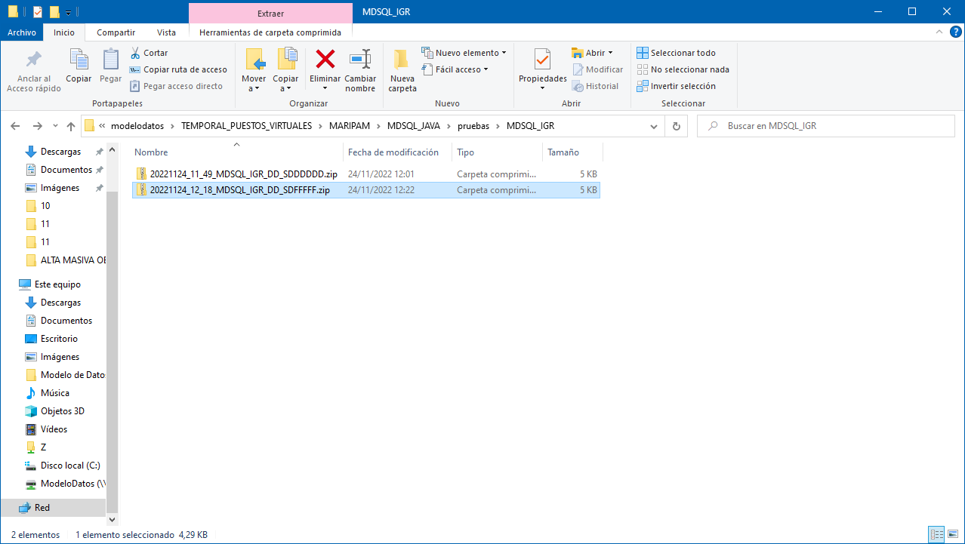

El error se ha producido al no incluir un comentario. Este campo es controlado por la lógica de negocio y cuando no está informado devuelve un error de negocio que hay que mostrar por pantalla. Si se incluye, funciona correctamente y entrega el procesado.

**V.2 (20221213) Continua produciéndose**